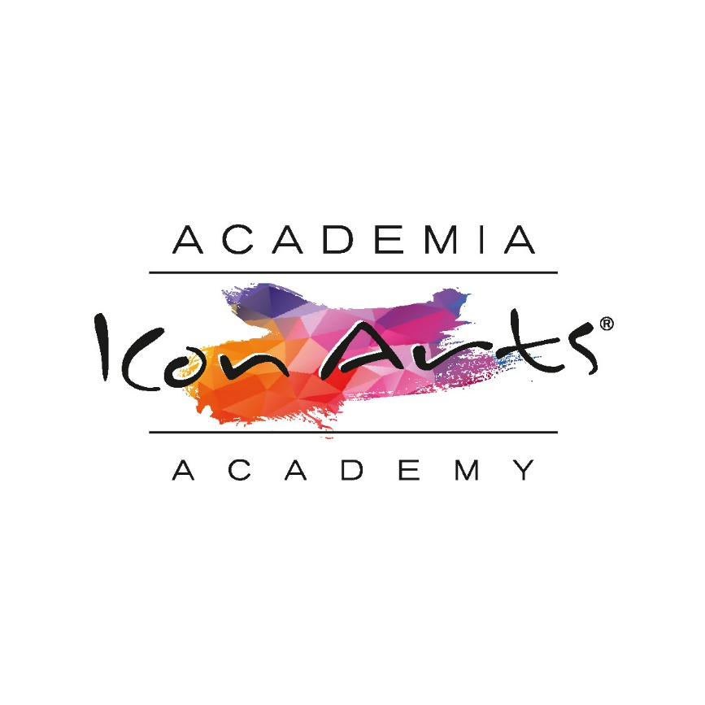

**Individual registration sheet with parental consent**

**at ICon Arts Transilvania Academy 2020**

The activity you are registering for: ICon Arts 2020 Academy

Organizers: Exces Music, UCIMR

Date: 25th of July – 2nd of August / 2nd – 10th of August

Location: Transylvania, Romania

I, ___________________________________________, parent of ___________________________________________, hereby consent that my son / daughter _________________________________________ participates in the activity that will take place under the conditions described in the invitation, and authorize the organizers and the accompanying adult ___________________________________ to do everything necessary for the safety of my son / daughter and the smooth running of the activity. I agree that photos of my son / daughter taken during the event may be used by the organizers only for non-commercial purposes and only to promote the image of ICon Arts Academy and Festival.

I confirm that I learned all about the conditions of the activity and that my son / daughter is fit for the average physical effort needed to carry out the activities of the event.

I agree that the organizers and the accompanying adult will not be held responsible for my son’s / daughter’s possible deviations from the rules of the event.

U.C.I.M.R. Statement regarding data protection:

We, the organizers, U.C.I.M.R., in relation to you, have the status of Personal Data Operator in accordance with the provisions of Regulation 2016/679 regarding the protection of natural persons with regard to the processing of personal data, and we will process your data exclusively in the fulfillment of the stated purpose, respectively your registration and conducting activities within the ICon Arts Transylvania 2020 Festival.

We are committed to maintaining the confidentiality of your data, not disclosing the data to third parties, maintaining the appropriate level of security to protect your data and maintaining it for a period that does not exceed the legal retention period. We also mention that, for the purpose of carrying out the activities, your data may be transmitted to other recipients (if you opt for accommodation - Hotel Unit)

For the exercise of the rights guaranteed under Regulation 2016/679 or for any other information regarding your personal data processed by us, please contact us at the e-mail address dpo@ucimr.ro, or in writing at the address 1-3 Valter Mărăcineanu Square Street, 5th floor, office 40, 1st district, Bucharest.

You also have the right to file a complaint with the National Authority for the Supervision of the Processing of Personal Data, having the contact details: telephone +40.318.059.211, email anspdcp@dataprotection.ro or to the address of Bucharest 1st district, 28-30 G-ral. Gheorghe Magheru Bldv..

Parents statement:

I hereby understand and agree that the organizers may use in the interest of promoting the event all the works and / or records from ICon Arts 2020 involving my child, consisting in publishing on the accounts held by the Organizer on social platforms (Facebook, Instagram, YouTube) and on the websites managed by Organizers.

Signature _______________________

I also understand that my child personal data voluntarily provided in the present Registration Agreement will be processed for the purpose of registering and participating in the activities mentioned above, held during the ICon Arts Transylvania 2020 Festival.

Parent signature, Date,