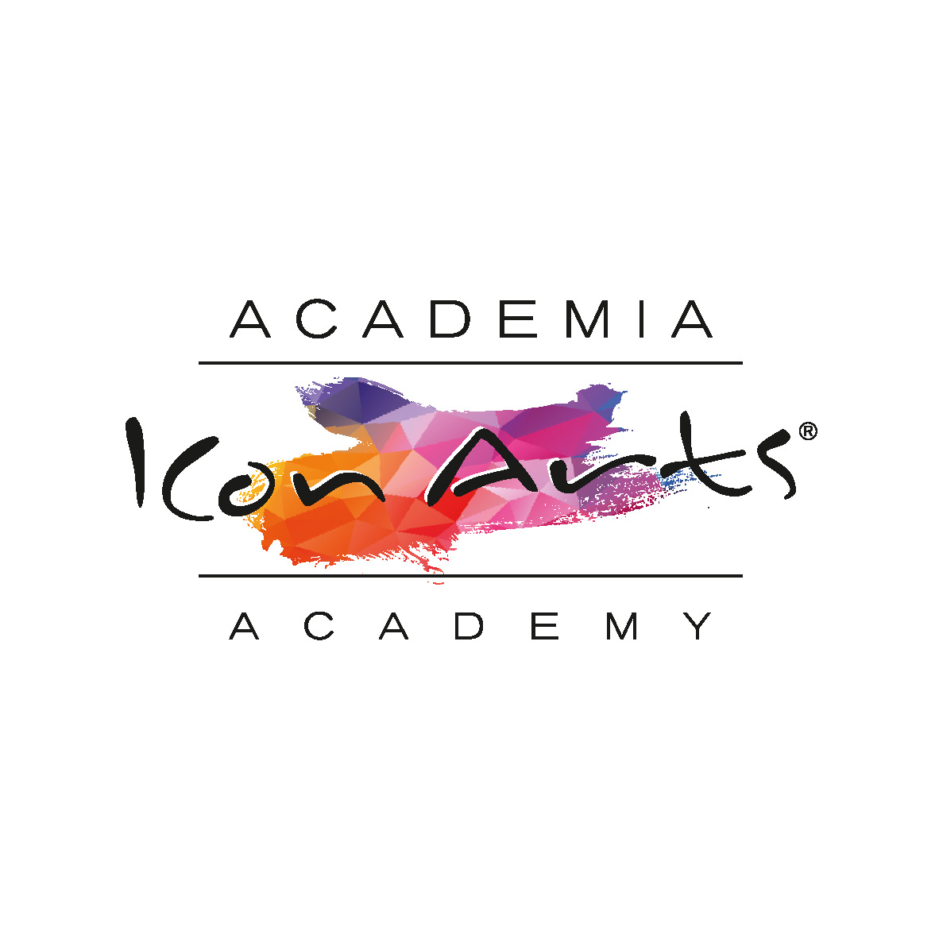

Surname ……………………………………. Name ……………………….…………...........
Address: ………………………...…………….…….….… City: ………………….…….........
Phone: …………….…, Mobile: ………………, e-mail:………………............……...............
Date of birth: ………………….....

I am applying for the 18th edition of ICon Arts Transilvania Academy and Festival 2020

Date:
 2 – 10 August 2019

Class:  Normania Songwriting Camp
 Theatre
 Jazz
 Performance - instrument ……………………..................
Special diet:
 Lacto-vegetarian
 Vegan
 Alergies ..............................................................................
 Other ……………………..................................................

Pick the desired package:
 200 EUR – advance payment
 500 EUR – full payment. Covers: accommodation, courses and 3 meals/ day, airport transfer (from Sibiu International Airport), transfer between concerts, tuition fees.

Payment to:

UCIMR – Uniunea de Creatie Interpretativa a Muzicienilor din Romania

Cont IBAN euro: RO17 BTRL EURC RT04 7708 8101
SWIFT: BTRLRO22
CIC: 4770881
Bank: Banca Transilvania
Sucursala Bucur Obor
PayPal: academia.iconarts@gmail.com

Cont IBAN lei 2500 lei:
RO40 BTRL RONC RT04 7708 8102
Banca Transilvania, Sucursala Bucur Obor

I hereby attach the copy of the payment order or of the bank statement.

I also agree that the organizers may use the works and / or recordings made during the ICon Arts 2020 at any time, in the interest of promoting the event, without any restriction or financial obligation.

Date ……………………., Signature, .......................................

